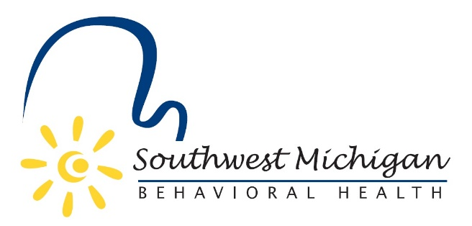

Southwest Michigan Behavioral Health (SWMBH) has been selected to receive a 2018 Above and Beyond Award from the Michigan Committee for Employer Support of the Guard and Reserve (ESGR). The ESGR is tasked with the mission of gaining and maintaining employer support for those who serve in the National Guard and Reserve. The Above and Beyond Award is given to those employers who provide a level of support “above and beyond” that required by law to their Guard and Reserve employees.
SWMBH was nominated for this award by Georgie (Braithwaite) Juday, it’s (now former) Veteran Navigator who serves as a 2nd LT in the Michigan National Guard. “We are both honored and humbled that Georgie would nominate SWMBH for this award,” said Bradley Casemore, SWMBH CEO. “We believe that supporting our nation’s active and reserve service men and women is important to maintaining SWMBH as a top employer. I want to personally thank Georgie for this nomination and for her exemplary work on behalf of veterans in our region. We will miss her as an employee, but wish her utmost success in her new full time position in service to our country in the Michigan National Guard.”

