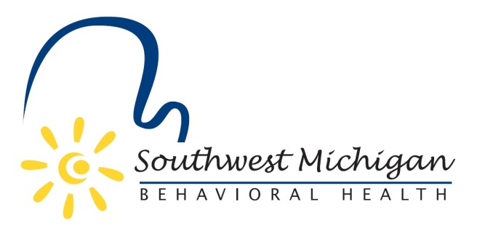

2018 Southwest Michigan Behavioral Health (SWMBH)
Substance Use Disorder Oversight Policy Board (SUDOPB) Member Roster

Barry County
SWMBH SUD/SUDOPB Staff and Support
- Bradley P. Casemore-Executive Officer
  - Brad.Casemore@swmbh.org
  - 269-488-6956
- Joel Smith- SUD Services Manager
  - Joel.Smith@swmbh.org
  - 269-488-6958
- Achiles Malta-SUD Prevention Specialist
  - Achiles.Malta@swmbh.org
  - 269-488-6925
- Michelle Jorgboyan-Senior Operations Specialist
  - Michelle.Jorgboyan@swmbh.org
  - 269-488-6845
- Ben Geiger
- VACANT

Berrien County
- Michael Majerek
- Debra Panozzo

Branch County
- Randall Hazelbaker-Chair
- VACANT

Calhoun County
- Steve Frisbie
- Kathy-Sue Vette

Cass County
- Tara Smith
- Skip Dyes

Kalamazoo County

- Lisa White
- Daniel Doehrman

St. Joseph County
- Allen Balog
- VACANT

Van Buren County
- Richard Godfrey-Vice Chair
- Paul Schincariol

*as of 02/07/18

