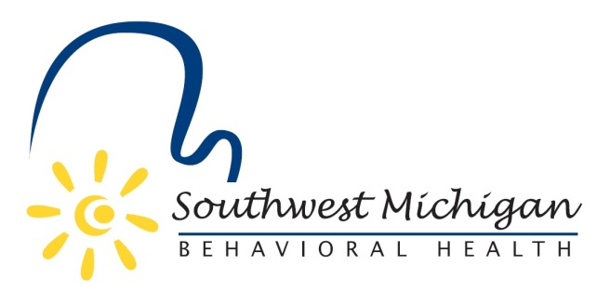
Southwest Michigan Behavioral Health
Substance Use Disorder Oversight Policy Board Meetings
2024
January 29, 2024 4:00-5:30pm
March 18, 2024 4:00-5:30pm
May 20, 2024 4:00-5:30pm
July 15, 2024 4:00-5:30pm
September 16, 2024 3:00-5:30pm
November 18, 2024 4:00-5:30pm

All meetings to take place at the Air Zoo Aerospace & Science Museum
6151 Portage Rd, Portage, MI 49002

SWMBH adheres to all applicable laws, rules, and regulations in the operation of its public meetings, including the Michigan Open Meetings Act, MCL 15.261 – 15.275
SWMBH does not limit or restrict the rights of the press or other news media.
Discussions and deliberations at an open meeting must be able to be heard by the general public participating in the meeting. Board members must avoid using email, texting, instant messaging, and other forms of electronic communication to make a decision or deliberate toward a decision and must avoid “round-the-horn” decision-making in a manner not accessible to the public at an open meeting.

