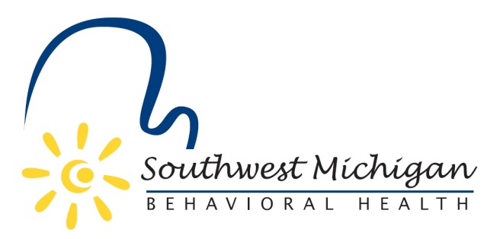

2022 Southwest Michigan Behavioral Health (SWMBH)
Substance Use Disorder Oversight Policy Board (SUDOPB) Member Roster

Barry County
SWMBH SUD/SUDOPB Staff and Support
- Bradley P. Casemore-Executive Officer
  - Brad.Casemore@swmbh.org
  - 269-488-6956
- Joel Smith- Substance Use Treatment & Prevention Director
  - Joel.Smith@swmbh.org
  - 269-488-6958
- Garyl Guidry- Senior Financial Analyst
  - Garyl.Guidry@swmbh.org
  - 269-488-6940
- Anastasia Miliadi- SUD Treatment Specialist
  - Anastasia.Miliadi@swmbh.org
  - 269-488-6963
- Achiles Malta-SUD Prevention Specialist
  - Achiles.Malta@swmbh.org
  - 269-488-6925
- Emily Flory-Opioid Health Home Coordinator
  - Emliy.Flory@swmbh.org
  - 269-488-6598
- Michelle Jacobs-Senior Operations Specialist & Rights Advisor
  - Michelle.Jacobs@swmbh.org
  - 269-488-6845
- Ben Geiger
- VACANT

Berrien County
- Michael Majerek
- Don Meeks

Branch County
- Randall Hazelbaker-Chair
- VACANT

Calhoun County
- Gary Tompkins
- Kathy-Sue Vette

Cass County
- Jeremiah Jones
- VACANT

Kalamazoo County

- Joanna McAfee
- Melissa Fett

St. Joseph County
- Jared Hoffmaster
- VACANT

Van Buren County
- Richard Godfrey-Vice Chair
- Paul Schincariol

*as of 1/21/2022

