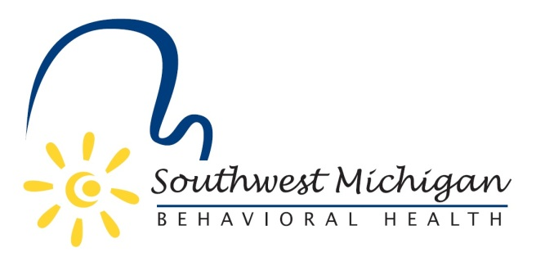

2026 Southwest Michigan Behavioral Health (SWMBH)
Substance Use Disorder Oversight Policy Board (SUDOPB) Member Roster

Barry County
SWMBH SUD/SUDOPB Staff and Support
- Mila Todd-Executive Officer
  - Mila.Todd@swmbh.org
  - 269-488-6794
- Joel Smith- Substance Use Treatment & Prevention Director
  - Joel.Smith@swmbh.org
  - 269-488-6958
- Garyl Guidry- Chief Financial Officer
  - Garyl.Guidry@swmbh.org
  - 269-488-6940
- Anastasia Miliadi- SUD Treatment Specialist
  - Anastasia.Miliadi@swmbh.org
  - 269-488-6963
- Achiles Malta-SUD Prevention Specialist
  - Achiles.Malta@swmbh.org
  - 269-488-6925
- Emily Flory-Strategic Initiatives Project Manager
  - Emliy.Flory@swmbh.org
  - 269-488-6598
- Amy St. Peter – Clinical Grants Specialist
  - Amy.StPeter@swmbh.org
- Michelle Jacobs-Senior Operations Specialist & Rights Advisor
  - Michelle.Jacobs@swmbh.org
  - 269-488-6845

- Marsha Bassett
- Vacant

Berrien County
- Alex R. Ott
- Rayonte Bell

Branch County
- Randall Hazelbaker-Chair
- Vacant

Calhoun County
- Dominic Oo
- Matt Saxton

Cass County
- RJ Lee
- Vacant

Kalamazoo County

- Jonathan Current
- Allyn Witchell

St. Joseph County
- Jared Hoffmaster-Vice Chair
- Vacant

Van Buren County
- Richard Godfrey
- Paul Schincariol

*as of 03/16/2026

