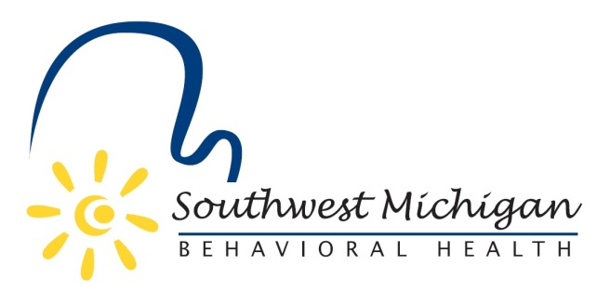
Southwest Michigan Behavioral Health
Substance Use Disorder Oversight Policy Board Meetings (January 2020-December 2020)
January 20, 2020 4:00-5:30pm
March 16, 2020 4:00-5:30pm
May 18, 2020 4:00-5:30pm
July 20, 2020 4:00-5:30pm
**September 14, 2020 3:00-5:30pm
Public Budget Hearing
November 16, 2020 4:00-5:30pm
COVID-19 Announcement:
In keeping with Governor Whitmer’s Executive Order 2020-15 SWMBH Board Meetings will be held electronically until the governor’s orders are lifted. Below are instructions for joining the SWMBH Board meetings:
From your computer, tablet or smartphone:
https://global.gotomeeting.com/join/250012069
Dial In: 1-844-655-0022
Access Code: 738 811 844
All scheduled meetings take place at the Principal Office, unless otherwise communicated.*
*Principal Office Located at 5250 Lovers Lane, Suite 200, Portage, MI, 49002
** KVCC - The Groves Center Room B1100, 7107 Elm Valley Drive, Kalamazoo, MI 49009

