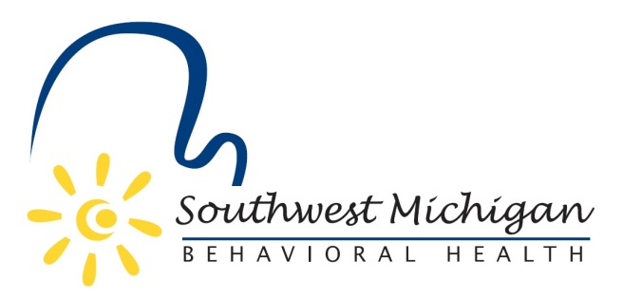
Southwest Michigan Behavioral Health
Substance Use Disorder Oversight Policy Board Meetings
2022
March 21, 2022 4:00-5:30pm
May 16, 2022 4:00-5:30pm
July 18, 2022 4:00-5:30pm
September 12, 2022 3:00-5:30pm
November 21, 2022 4:00-5:30pm (meeting at SWMBH, 5250 Lovers Lane, Suite 200, Portage, MI 49002)

All scheduled meetings take place at Four Points by Sheraton, 3600 E. Cork St. Kalamazoo, MI 49001 unless otherwise noted

SWMBH adheres to all applicable laws, rules, and regulations in the operation of its public meetings, including the Michigan Open Meetings Act, MCL 15.261 – 15.275
SWMBH does not limit or restrict the rights of the press or other news media.
Discussions and deliberations at an open meeting must be able to be heard by the general public participating in the meeting. Board members must avoid using email, texting, instant messaging, and other forms of electronic communication to make a decision or deliberate toward a decision and must avoid “round-the-horn” decision-making in a manner not accessible to the public at an open meeting.

