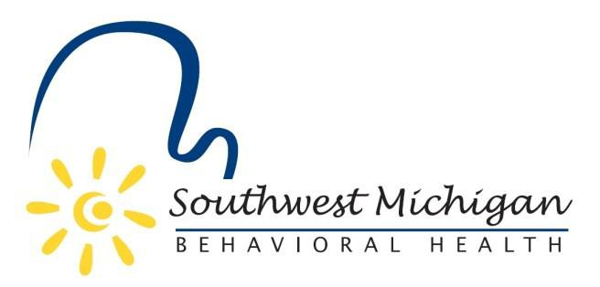
Southwest Michigan Behavioral Health Board Meetings
2023

January 13, 2023 – 9:30am to 11:30am
February 10, 2023 – 9:30am to 11:30am
*Meeting canceled - March 10, 2023 – 9:30am to 11:30pm
April 14, 2023 – 9:30am to 11:30am
*Meeting canceled - May 12, 2023 – 9:30am to 11:30am
May 12, 2023 – 9:30 to 3:00pm Board Retreat
June 9, 2023 – 9:30am to 11:30am
July 14, 2023 – 9:30am to 11:30am
August 11, 2023 – 9:30am to 11:30am
September 8, 2023 – 9:30am to 11:30am
October 13, 2023 – 9:30am to 11:30am
November 10, 2023 – 9:30am to 11:30am
December 8, 2023 – 9:30 am to 11:30am
All scheduled meetings take place at the Four Points by Sheraton, 3600 E. Cork St. Kalamazoo, MI 49001

All SWMBH Board Meetings are subject to the Open Meetings Act 1976 PA 267, MCL 15.261-15.275
SWMBH adheres to all applicable laws, rules, and regulations in the operation of its public meetings, including the Michigan Open Meetings Act, MCL 15.261 – 15.275

SWMBH does not limit or restrict the rights of the press or other news media.
Discussions and deliberations at an open meeting must be able to be heard by the general public participating in the meeting. Board members must avoid using email, texting, instant messaging, and other forms of electronic communication to make a decision or deliberate toward a decision and must avoid “round-the-horn” decision-making in a manner not accessible to the public at an open meeting.

