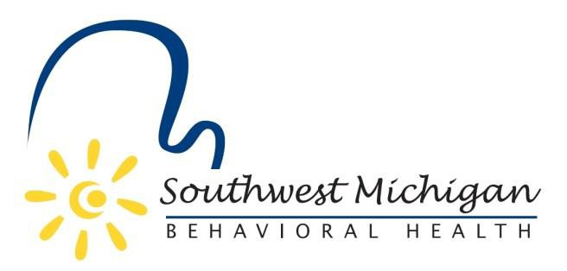
Southwest Michigan Behavioral Health Board Meetings
2024
Air Zoo Aerospace & Science Museum
6151 Portage Rd, Portage, MI 49002

January 12, 2024 – 9:30am to 11:30am -meeting cancelled
February 9, 2024 – 9:30am to 11:30am
March 8, 2024 – 9:30am to 11:30pm
April 12, 2024 – 9:30am to 11:30am
*May 10, 2024 – 9:30am to 10:30am at Bay Pointe Inn
*May 10, 2024 – 10:30 to 3:00pm Board Planning Session at Bay Pointe Inn
June 14, 2024 – 9:30am to 11:30am
July 12, 2024 – 9:30am to 11:30am
August 9, 2024 – 9:30am to 11:30am
September 13, 2024 – 9:30am to 11:30am
October 11, 2024 – 9:30am to 11:30am
November 8, 2024 – 9:30am to 11:30am
December 13, 2024 – 9:30 am to 11:30am

*Bay Pointe, 11456 Marsh Rd, Shelbyville, MI 49344

All SWMBH Board Meetings are subject to the Open Meetings Act 1976 PA 267, MCL 15.261-15.275
SWMBH adheres to all applicable laws, rules, and regulations in the operation of its public meetings, including the Michigan Open Meetings Act, MCL 15.261 – 15.275

SWMBH does not limit or restrict the rights of the press or other news media.
Discussions and deliberations at an open meeting must be able to be heard by the general public participating in the meeting. Board members must avoid using email, texting, instant messaging, and other forms of electronic communication to make a decision or deliberate toward a decision and must avoid “round-the-horn” decision-making in a manner not accessible to the public at an open meeting.

