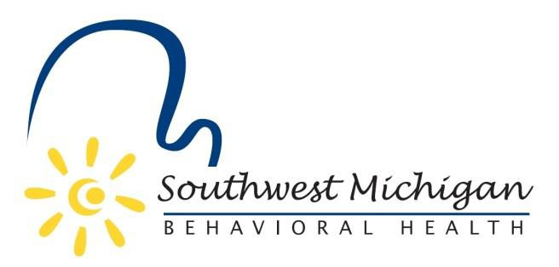

**Southwest Michigan Behavioral Health Board Meetings**

**2025**

**Air Zoo Aerospace & Science Museum**

**6151 Portage Rd, Portage, MI 49002**

January 10, 2025 – 9:30am to 11:30am

February 14, 2025 – 9:30am to 11:30am

March 14, 2025 – 9:30am to 11:30pm

April 11, 2025 – 9:30am to 11:30am

May 9, 2025 – 9:30am to 10:30am

May 9, 2025 – 10:30 to 3:00pm Board Planning Session

*June 13, 2025 – 9:30am to 11:30am

July 11, 2025 – 9:30am to 11:30am

**August 1, 2025 – 2:00pm to 3:00pm

August 8, 2025 – 9:30am to 11:30am

**August 27, 2025 12:00pm to 1:00pm

**September 12, 2025 – 9:30am to 11:30am

October 10, 2025 – 9:30am to 11:30am

November 14, 2025 – 9:30am to 11:30am

December 12, 2025 – 9:30 am to 11:30am

*Advia Credit Union, 6400 West Main St. Kalamazoo, MI 49009

**Southwest Michigan Behavioral Health, 5250 Lovers Lane, Suite 200, Portage. MI 49002

All SWMBH Board Meetings are subject to the Open Meetings Act 1976 PA 267, MCL 15.261-15.275

SWMBH adheres to all applicable laws, rules, and regulations in the operation of its public meetings, including the Michigan Open Meetings Act, MCL 15.261 – 15.275

SWMBH does not limit or restrict the rights of the press or other news media.

Discussions and deliberations at an open meeting must be able to be heard by the general public participating in the meeting. Board members must avoid using email, texting, instant messaging, and other forms of electronic communication to make a decision or deliberate toward a decision and must avoid “round-the-horn” decision-making in a manner not accessible to the public at an open meeting.