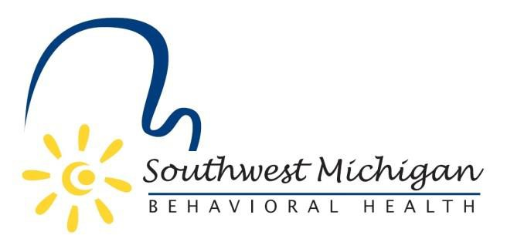
Southwest Michigan Behavioral Health Board Meetings
2025
Southwest Michigan Behavioral Health
5250 Lovers Lane, Suite 200, Portage, MI 49002

January 10, 2025 – 9:30am to 11:30am
February 14, 2025 – 9:30am to 11:30am
March 14, 2025 – 9:30am to 11:30pm
April 11, 2025 – 9:30am to 11:30am
May 9, 2025 – 9:30am to 10:30am
May 9, 2025 – 10:30 to 3:00pm Board Planning Session
*June 13, 2025 – 9:30am to 11:30am
July 11, 2025 – 9:30am to 11:30am
**August 1, 2025 – 2:00pm to 3:00pm
August 8, 2025 – 9:30am to 11:30am
**August 27, 2025 12:00pm to 1:00pm
**September 12, 2025 – 9:30am to 11:30am
**October 10, 2025 – 9:30am to 11:30am
**November 14, 2025 – 9:30am to 11:30am
**December 12, 2025 – 9:30 am to 11:30am

*Advia Credit Union, 6400 West Main St. Kalamazoo, MI 49009
**Southwest Michigan Behavioral Health, 5250 Lovers Lane, Suite 200, Portage. MI 49002

All SWMBH Board Meetings are subject to the Open Meetings Act 1976 PA 267, MCL 15.261-15.275
SWMBH adheres to all applicable laws, rules, and regulations in the operation of its public meetings, including the Michigan Open Meetings Act, MCL 15.261 – 15.275

SWMBH does not limit or restrict the rights of the press or other news media.
Discussions and deliberations at an open meeting must be able to be heard by the general public participating in the meeting. Board members must avoid using email, texting, instant messaging, and other forms of electronic communication to make a decision or deliberate toward a decision and must avoid “round-the-horn” decision-making in a manner not accessible to the public at an open meeting.

