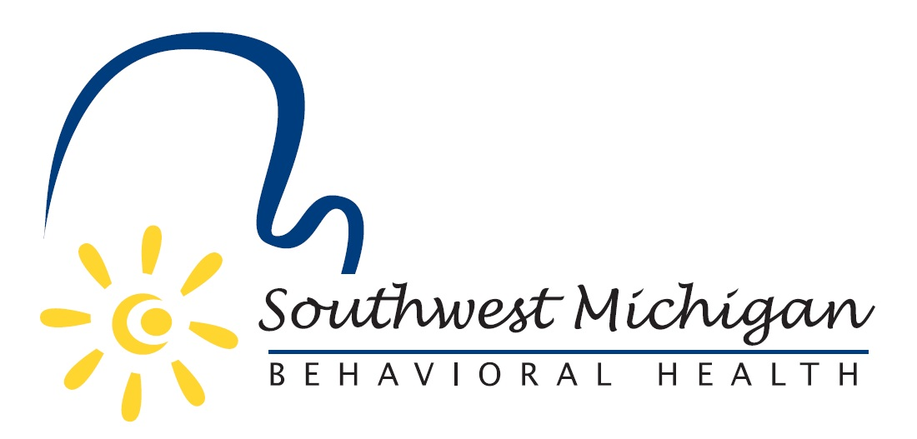
Southwest Michigan Behavioral Health
Special Board Meeting
SWMBH – Moses L. Walker Community Room
5250 Lovers Lane, Suite 200, Portage, MI 49002
August 1, 2025
2:00 pm to 3:00 pm
Draft: 7/30/25

- Welcome Guests/Public Comment

- Agenda Review and Adoption

- Discussion of purpose for today’s special meeting
  - Sign the separation agreement for our executive officer
  - Approve the joint announcement of separation for the community
  - Approve the succession plan for executive leadership

- Public Comment

- Adjournment

SWMBH adheres to all applicable laws, rules, and regulations in the operation of its public meetings, including the Michigan Open Meetings Act, MCL 15.261 – 15.275.

SWMBH does not limit or restrict the rights of the press or other news media.

Discussions and deliberations at an open meeting must be able to be heard by the general public participating in the meeting. Board members must avoid using email, texting, instant messaging, and other forms of electronic communication to make a decision or deliberate toward a decision and must avoid “round-the-horn” decision-making in a manner not accessible to the public at an open meeting.

