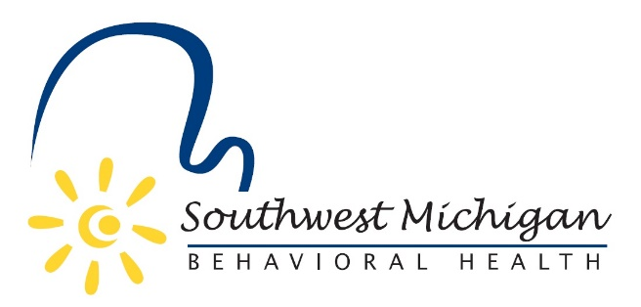

Southwest Michigan Behavioral Health (SWMBH) has been selected to receive a 2018 Hometown Hero Award from the Michigan Public Health Week Partnership in celebration of National Public Health Week. The Michigan Public Health Week Partnership is comprised of 10 public entities in the State of Michigan, just a few of which include the Michigan Department of Health and Human Services, Michigan Public Health Association, Michigan Public Health Institute as well as many state university public health departments.
This award recognizes individuals and organizations across the state working to improve the health of their local communities. SWMBH was nominated for the award in recognition of their Naloxone/Narcan training and distribution opioid overdose prevention program that since 2016 has trained law enforcement and community members on the administration of Naloxone/Narcan. Over 1482 free kits have been distributed to law enforcement in their eight county region and training has occurred for 59 participating Law Enforcement/Fire Fighting agencies and 2,052 community members. At the time of the nomination the program had reversed 202 known overdoses.

